**Principles of Microeconomics**

**Group Project**

**Semester 1, 2020**

## Name: 谢泰宇、初众、苏咏潇、谢家圆、傅宇杰

**Class: 2**

**Date of Submission: 2021.1.2**

1. **Introduction**

*This year,we have all been experiencing too much appalling matters that touches our hearts or ignites our dander,  excites our nerves or contaminates our social environment.*

*We suddenly find that we are just the unprecedented witnesses of history , and of course ,we are creating the times.*

*This year,  we have become a member of RUC,and RMBS,  studying economics. Just as what we always regard ourselves as the leaders of society , we must , and have to apply what we have learned in economics to the reality in the world so as to burden the responsibility we ought to carry.*

*So, this report just gives us a vivid account of lately events in five sectors , like the monopoly in Internet, the externality of high-speed rail the trade war between Australia and China , the discrimination from the oligopoly realm and the government’s actions in agriculture .*

*We are thirsty for the combination of our passion for our nation and the knowledge we have learned in economics classes , which is the reason why we wrote these articles .*

*Thanks for anyone who is always  by our side and dear Dc. Wang Zijia .*

## Discussion

**Newspaper Article #1**

*Article Title: 京福高铁即将全线贯通 新高铁经济圈呼之欲出*

*Article URL: <http://finance.people.com.cn/n/2015/0626/c1004-27209432.html>*

*Microeconomics concept discussed: externality*

***The positive externality of China high-speed rail------taking Jingfu high-speed rail as an example***

*From the study of The principle of economics this term ,we figure out that the externality is the uncompensated impact of one person’s actions on the well-being of a bystander.As an important form of infrastructure ,The high-speed rail is embeded into the national developing strategy. So it’s beneficial to analyse its externality so as we could properly adjust the construction of high-speed railway and realize the whole development of society.*

*From Beijing to Fuzhou, the Jingfu high-speed rail whose length is nearly 2000 miles, is a vital part of the‘eight horizontal and eight vertical’ distribution, ,which is mean to link JINGJINJI and CHANGSANJIAO and ZHUSANJIAO. It was just born in 2015 and owns lots of reference meanings.*

*So, this report just reveals the externality of China high-speed rail taking Jingfu as an example*

*.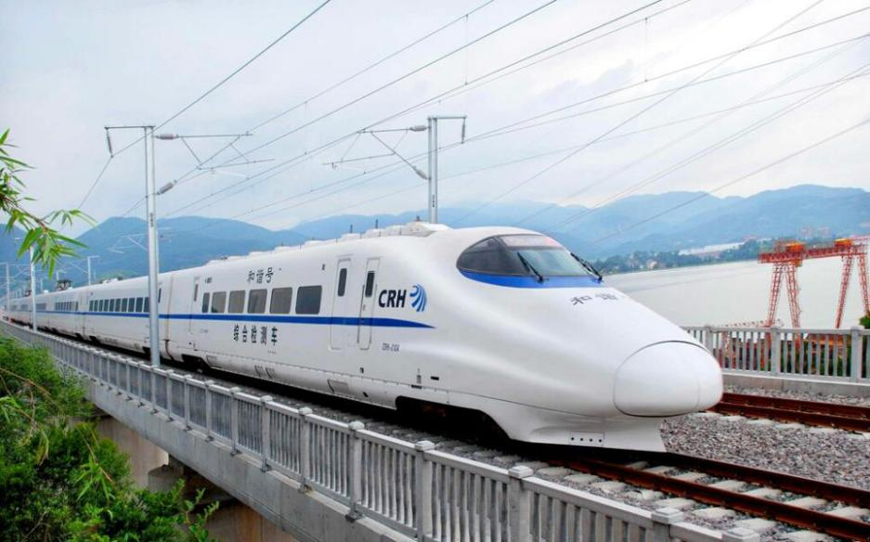*

*The analysis of its positive externality*

*Here we analyze the externality of China high-speed rail, hoping to explore the reasons for the rapid development of China high-speed rail and analyze other benefits beyond the market factors. Although the construction of China's high-speed railway is controlled by the state and there is no clear supply and demand curve, the prosperity and development of China high-speed railway for so many years shows that the effect of state controlling is the same as that of "invisible hand", which can be briefly analyzed from the perspective of market.*

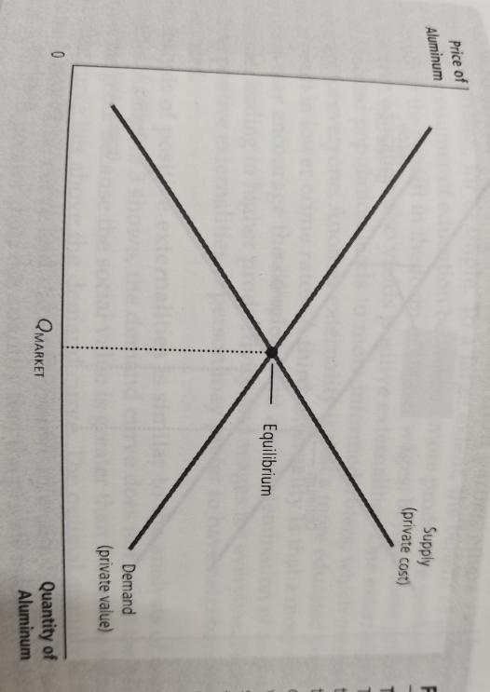

*First, let's look at what the positive externality of high-speed rail brings. Similar to the illustrations in the textbook, at this time, due to the existence of external benefits, the demand curve moves upward, and the supply and demand form a new equilibrium. According to the knowledge of welfare economics, we can conclude from the graph that the total surplus is increased and the social benefits are increased.*

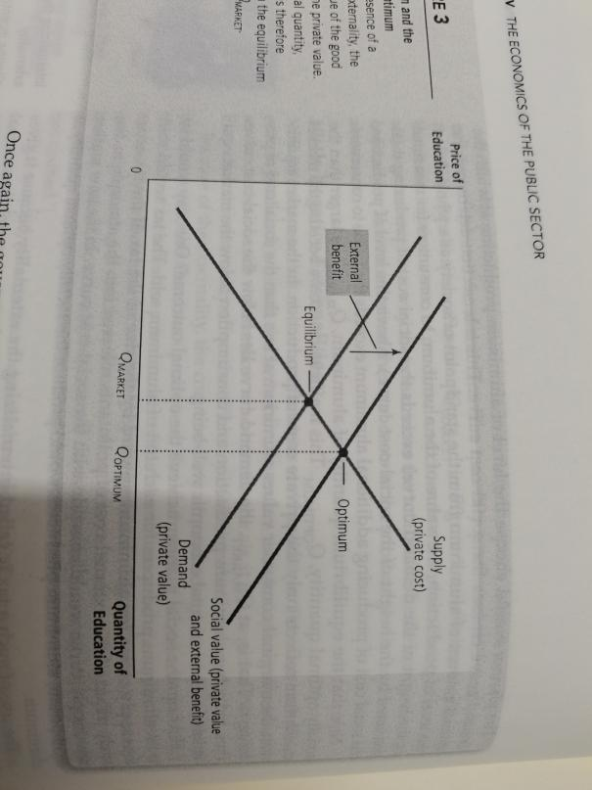

*Externality1. the local economic development*

*We take Hefei and Quanzhou that are the location of two important stations of this line as examples.*

*The following picture shows the GDP of Quanzhou these years.*

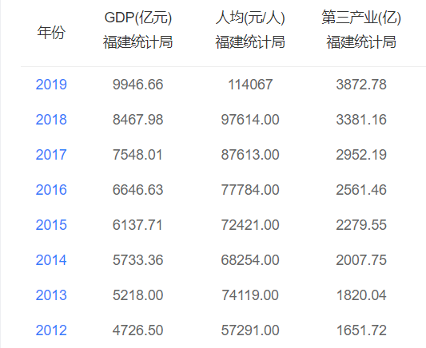

*This picture shows the GDP of Hefei these years.*

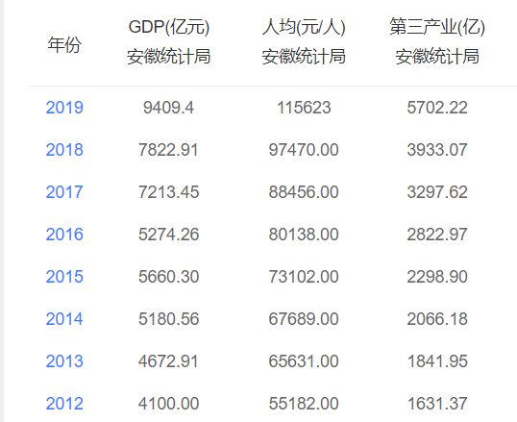

*As I have written ,this line was born in 2015 .According these statistics , through calculation, we could know that the average rate of increasing GDP of Hefei from*

*2012 to 2015 is 11.34% ,while it is 21.28% from 2016 to 2019 and it is experiencing a rapid increase since the existence of Jingfu .*

*The same is as Quanzhou as its average rate of increasing GDP is 9.01% from 2012-2015, while it is 14.38% from 2016 to 2019.*

*Maybe you could ask why I contribute this increase to the Line .My reason is brought by National Development and Reform Commission who said the contribution of the high-speed rail to rural economic development is up to 3.54%.*

*So, when it comes the aspect of the local economic development, we could say the high-speed rail plays a fascinating role that shows powerful externality.*

*Externality2. the strength of related technology*

*As the President Xi said, high speed rail is a beautiful business card of our country and a leading industry that makes us more upright. It involves many technical problems and has a great density of scientific and technological patents.*

*According to the "technology spillover" mentioned in the textbook, the impact of one enterprise's research and production efforts on other enterprises' access to technological progress. The total number of patent applications in China disclosed by the listed companies in the high-speed rail industry is 1783, of which the number of utility model patent applications is the largest, with 1007.*

*The substantial innovation of science and technology has enhanced the overall technical strength of our country and accelerated the overall development of society.*

*Externality3. improving the “One belt and one road” strategy*

*China high-speed rail construction has been obvious achievements in recent years, and has unique advantages. Making full use of the advantages of China high-speed rail and constructing a transportation network connecting the countries along the belt will benefit the early realization of the concept of "one belt and one road" initiative.*

*Especially in the high speed rail and other infrastructure areas, Southeast Asia has a considerable gap and potential for development. Under the one belt and one road, the cooperation of high-speed rail projects will become an important way to achieve a win-win cooperation with Southeast Asian countries.*

*Like Quanzhou,*

*Externality4. ensuring the security of national defence*

*The construction of high-speed railway is of special significance for improving the overall layout of transportation, enhancing the ability of military transportation support, and ensuring territorial and military security.*

*General secretary Xi repeatedly proposed that we should vigorously strengthen our strategic delivery capability so as to ensure that the troops should be in the first place.*

*The development of high-speed railway will enable military operations to gain time and opportunities, create conditions for the realization of fewer and better troops, and play an important role in comprehensively enhancing the rapid and large-scale mobility of our army and promoting the modernization of national defense.*

*To put it shortly, The positive externalities of high-speed rail, which cover a wide range and have far-reaching effects, deserve our careful analysis and deep grasp, so as to better integrate high-speed rail into the situation of national development strategy.*

*How to go further:*

*The high-speed rail shows insignificant positive externality ,and according to the economic knowledge we studied this term----The government sometimes could improve the market out come ,we could realize the government should give it proper subsidy so as to ensure the demand curve could move to a suitable position and increases the total surplus.*

*And The state has given full financial support to the construction of high-speed rail. According to the latest data released by the State Railway Administration, the investment of China railways will reach 802.8 billion yuan in 2018 and 800 billion yuan in 2019.*

*From everything depicted above ,as the high-speed railway plays an increasingly important role in the future economic development, we should pay more attention to its externality and reasonably adjust its subsidies in order to maximize the utility to realize efficiency and also equality.*

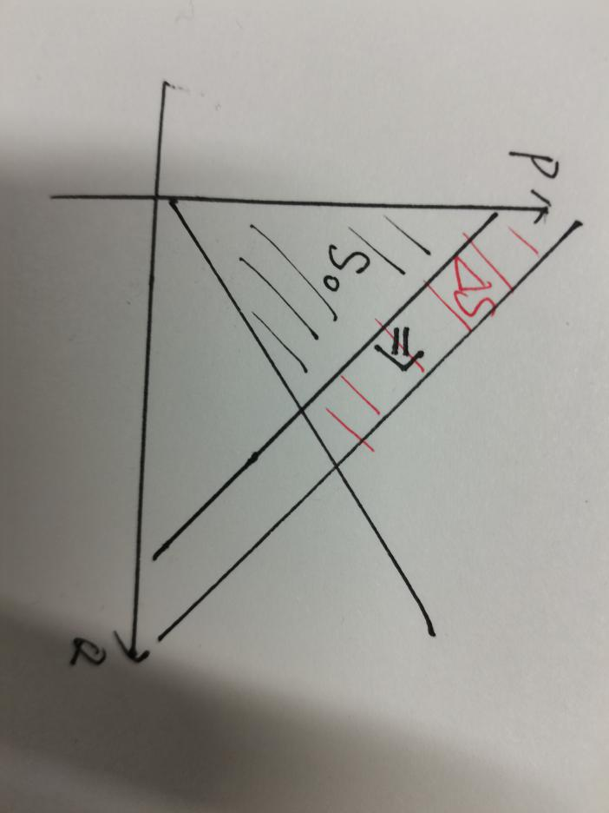

## Newspaper Article #2

*Article Title: China's Internet industry market has become an oligopoly pattern*

*Article URL: <https://xw.qq.com/cmsid/20201119A0EET700?f=newdc>*

*Microeconomics concept discussed: Oligarchy, monopolistic competition, game theory,predatory pricing*

*(Write your analysis here, accompanied with suitable Microeconomics graphs, tables, computations etc)*

*From scratch, from small to large, and from large to strong, Chinese Internet industry has gradually begun to monopolize the market, led by Tencent and Alibaba. China's Internet industry market has become an oligopoly pattern, which poses a threat to the development of small and medium-sized enterprises.*

*From 2008 to 2018, there were 40 monopoly disputes in the competition among Internet enterprises, of which 20 cases involved enterprises with a market share of more than 30%. 12 enterprises were listed in the top 100 Internet enterprises in China in 2018, among which Alibaba, Tencent, Baidu, Jingdong and Netease ranked first to fifth respectively.*

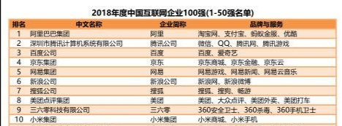

*Taking the e-commerce platform as an example, the inquiry data shows that Alibaba's online sales share in 2019 accounts for 55.9%, far exceeding other online retail service platforms. In addition to Alibaba, JD and Pinduoduo account for 16.7% and 7.3% respectively, and their online sales share is relatively prominent. China's online retail market has formed an oligopoly pattern.*

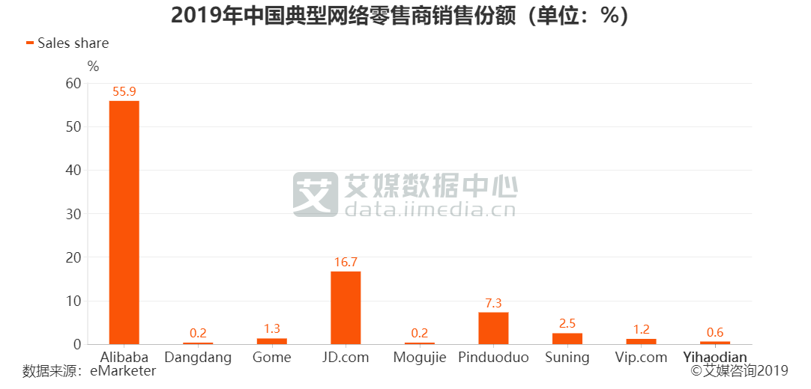

*Through mergers and acquisitions, cooperation and other ways, Internet giants have infiltrated the enterprise ecological layout into the daily life of the public, and gradually evolved into the competition between Internet ecosystems with user resources as the core.*

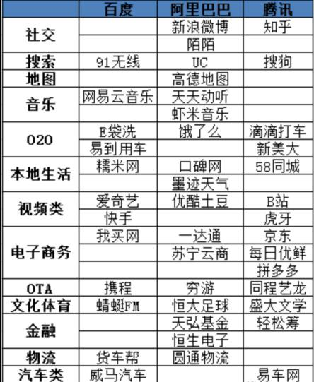

*This table lists the enterprises that bat mainly acquired (including strategic shares) from 2010 to 2019, and the position of China's Internet leader is completely monopolized by the three giants.*

*Recently, Pinduoduo and Meituan successively cut into community group buying with low price strategy. At Meituan's group festival held in Xi'an on November 12, almost all the commodities participating in the activities are below 40% discount. In just 12 hours, Wallace hamburger, one of the businesses settled in, sold nearly 30000 orders, with sales of 800000 yuan. This kind of low price promotion reminds us of Pinduoduo's low price strategy, which made it one of the top three e-commerce companies in five years. This kind of predatory pricing will force competitors to withdraw from the market, and then they will set the monopoly price in the oligopoly or monopoly pattern. This will seriously weaken the industry competition and accelerate the process of monopoly, which should be punished by the anti-monopoly law.*

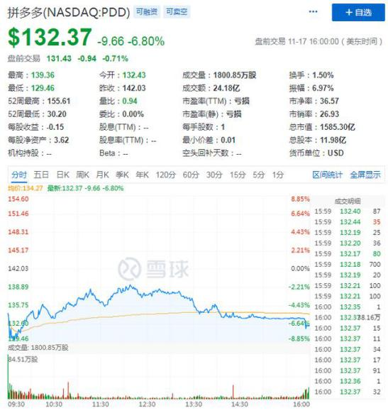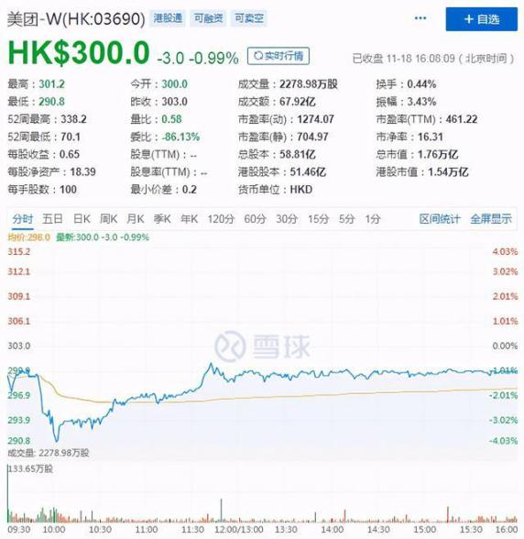

*（Through the low price strategy to enter the field of community group buying, Meituan and Pinduoduo's share prices rose better this year）*

*In order to earn economic profits, oligarchic enterprises will control the production quantity below the effective quantity, thus making the market inefficient. If various industries collude with each other to maximize their own interests and form cartels, they will achieve monopoly effect and seriously threaten the development of the Internet industry.*

*However, because the Internet industry is profitable, more and more enterprises will choose to enter the market, and the supply curve will move to the right, which will lead to the decline of prices and the gradual reduction of economic profits to zero. As a result, the oligopoly market will gradually develop into a fully competitive market, and the price effect will disappear.*

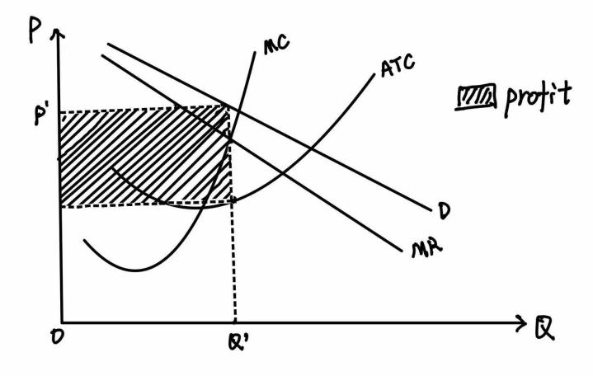

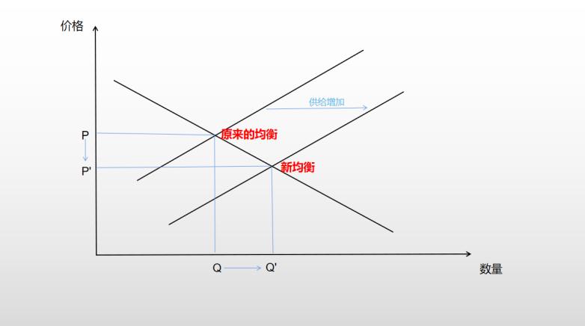

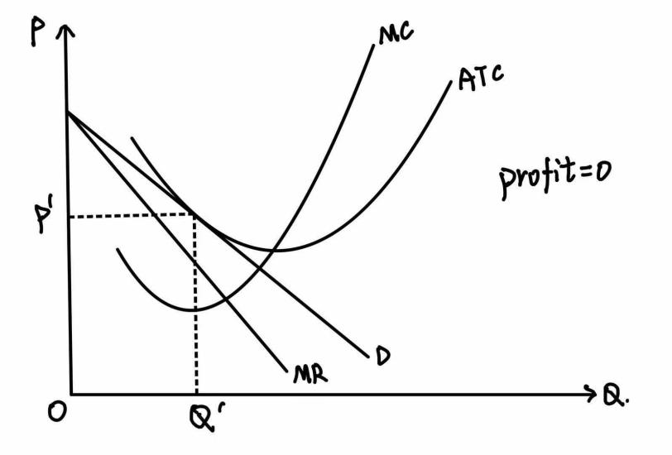

*For the enterprises that are already in the market, in order to prevent the losses caused by the other party's deception, each enterprise will make strategies based on the principle of maximizing its own interests, which makes cooperation difficult. The Nash equilibrium will reduce monopoly profits and increase consumer surplus. On the other hand, the gradually entering enterprises will gradually expand the market scale In addition, the existence of antitrust law makes it difficult to reach and implement agreements.*

*Therefore, on the whole, we need not worry too much about the current oligopoly situation in the Internet industry, which will be greatly improved in the near future if the government is well managed.*

## Newspaper Article #3

*Article Title: Australian barley, the Ministry of Commerce has finally made a move*

*Article URL: <https://m.nbd.com.cn/articles/2020-05-19/1435716.html>*

*Microeconomics concept discussed: International trade;Import;Tariff*

*Abstract of the news:On May 18, the Ministry of Commerce issued announcements No. 14 and No. 15 of 2020, announcing the final ruling on the anti-dumping investigation and countervailing investigation of imported barley originating in Australia. It ruled that there were dumping and subsidies on imported barley originating in Australia, and the domestic industry suffered material damage, and there was a causal relationship between dumping and subsidies and material damage. It decided to start from May 19, 2020 The anti-dumping duty and countervailing duty are levied on the above-mentioned products. The anti-dumping duty rate is 73.6%, the countervailing duty rate is 6.9%, and the collection period is five years.*

*Analysis:In this news,we can see the international trade between China and Australia,one of the “one belt,one road” cooperation country.First,let’s explore why China is an importer in barley trade with Australia.China's domestic barley production capacity is relatively insufficient. If we rely entirely on domestic supply, barley prices will be rather high.However, in the world market, especially in Australia, barley prices are significantly lower than domestic prices because Australia barley production is sufficient,suggesting that Australia has a comparative advantage in producing barley.So,when the international market is open, domestic consumers will tend to buy foreign low-cost barley, then China becomes a barley importing country.Next,let’s analyse the gains and losses of China from importing barley.Here is a model diagram to simplify the hypothesis.*

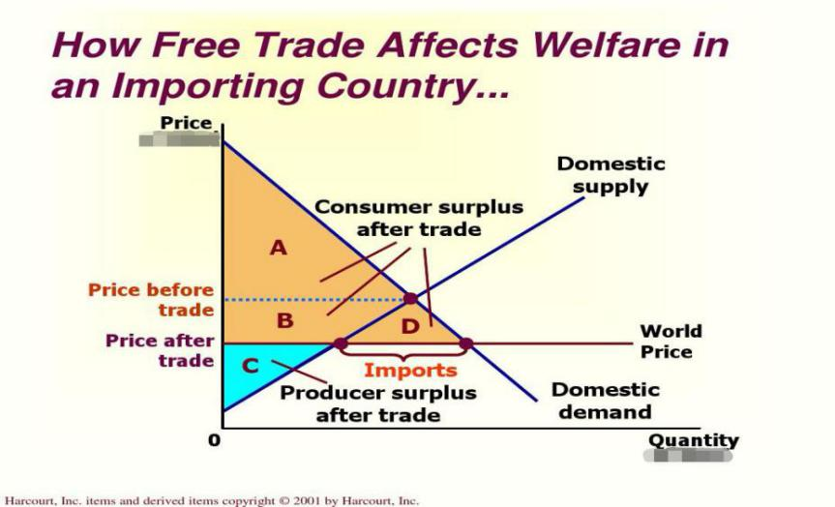

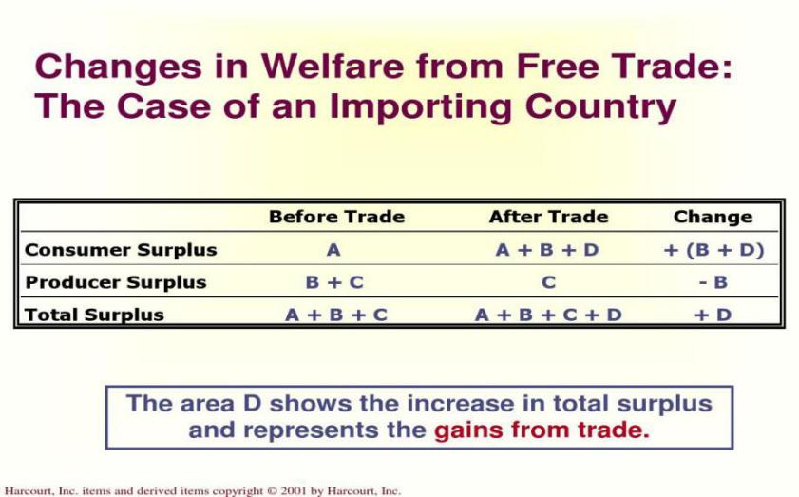

*As we can see,when a country allows trade and becomes an importer of a good，domestic consumers of the good are better off,and domestic producers of the good are worse off.Although trade raises the economic well-being of a nation,however,in the actual situation of barley trade between China and Australia, domestic barley producers’ surplus decreases a lot.According to China's statistics, in recent years, barley imports from Australia have "increased in volume and decreased in price" significantly. Among them, the import volume increased from 3.8771 million tons in 2014 to 6.4804 million tons in 2017, a significant increase of 67.14%; the import price decreased from 288.72 dollars per ton in 2014 to 198.05 dollars per ton in 2017, a decrease of more than 31%. Affected by this, the barley planting area in China decreased by about 14% in the same period.Why would this kind of situation happen?So now,let's go back to dumping and anti-dumping. Although international trade can promote competition, Australia has started vicious competition in this trade,which are dumping and countervailing.Australia deliberately lowers export prices and subsidizes their firms in order to squeeze out domestic barley producers in China and further occupy the Chinese market with ultra-low prices. In order to protect the legitimate interests of domestic producers and resist the inequity and injustice, China has adopted the measures of imposing tariffs.So,what’s the impact of a tariff?*

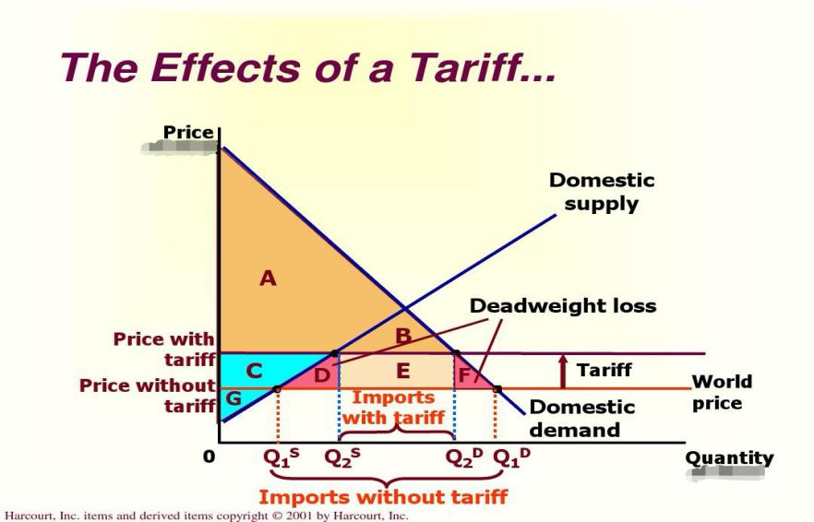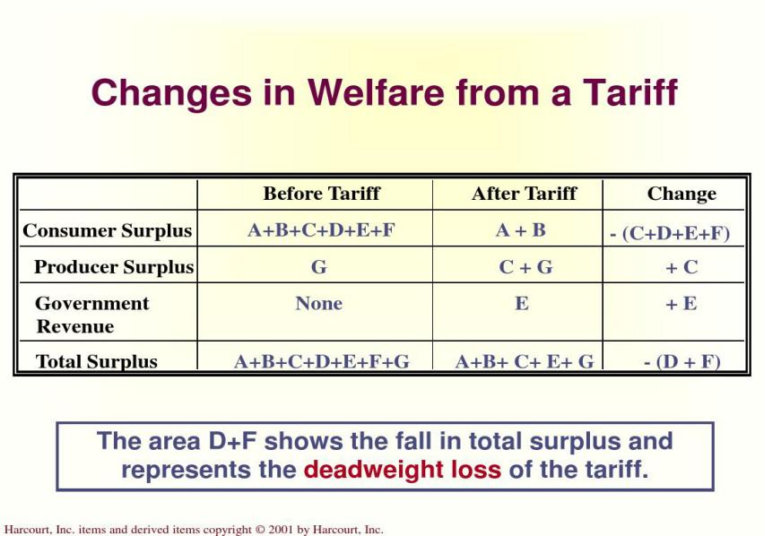

*From the pictures we can see,although a tariff can decrease the total surplus and cause a deadweight loss,it makes domestic producers better off,which means in reality China has sacrificed part of the overall surplus to protect the interests of domestic producers.Restricting the trade where dumping exists on the one hand protects the interests of Chinese producers, on the other hand, it optimizes the domestic market structure.*

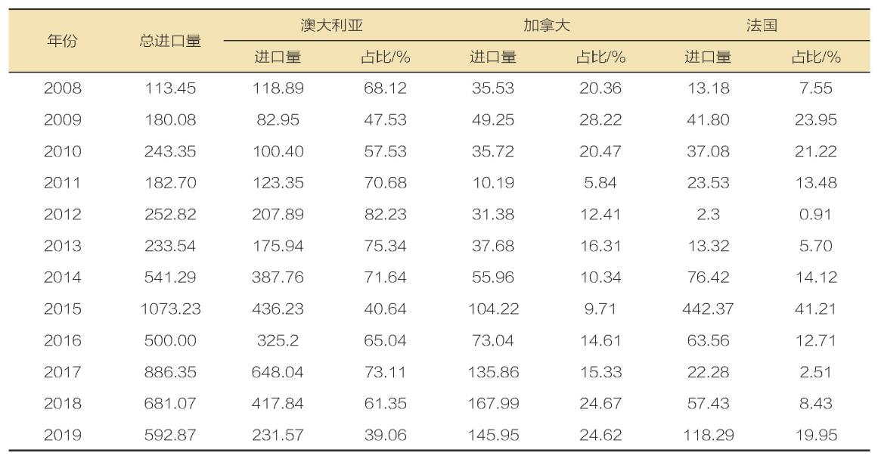

*Here is China’s recent-year barley import data table.As we can see,China imposes anti-dumping and countervailing duties on Australian barley, which is the main reason of making domestic demand shift to other countries. Because of the huge demand of barley market in China, this will undoubtedly cause the world price to rise.*

*To make a summary,international trade is good for all parties in most cases. But a country needs to control and analyze the current situation of trade, and sometimes has to restrict trade to protect the stability of the domestic market. However, if the trading parties follow the principle of mutual benefit and mutual respect,similar incidents would probably not happen.And from this news,we have a deeper understanding of  what we have learned from Mankiw's principles of microeconomics and how we should use it in specific situations.*

## Newspaper Article #4

*Article Title: The Price Discrimination in Meituan's Pricing Products to the Disadvantage of Existing Costumers.*

*Article URL: https://s.cyol.com/articles/2020-12/18/content_DMZzbBhn.html?gid=2Zr5Oake*

*Microeconomics concept discussed: Price discrimination;Surplus*

*In this internet era, takeaway is more and more popular for it's convenience. In order to save some money, some of us may choose to buy a membership. However, an article l posted on 14th, December suggested that a man with membership may pay more compared to those without membership in Meituan APP.*

*This is a kind of price discrimination establishing on asymmetric information. In the following part, we will take about what it brings to sellers, buyers and the whole society.*

*To the sellers, obviously, this kind of price discrimination can bring more profits for them in the short run. But we should notice that Meituan is not a monopoly firm. It's in a competitive market, which causes it's users can tend to others when they notice the price discrimination. That is, the profits will decline in the long run. Of course, we can't ensure there is no price discrimination in other APPs.*

*To the buyers, who the price discrimination do affect are those with membership. To these people, their surplus decline because their willingness to pay keeps the same while the price increases.*

*To the society, the whole surplus remains the same. The price discrimination just transfer consumer surplus to producer surplus.*

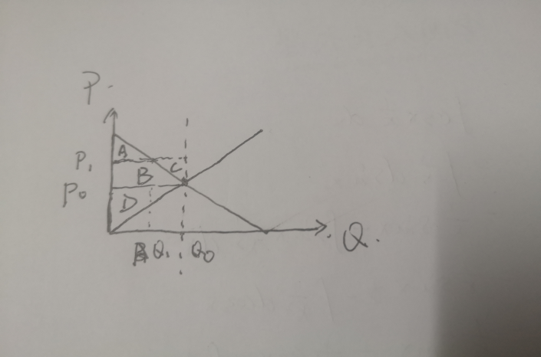

*Like this graph, at first, the market is equilibrium. And the consumer surplus is A+B, while producer surplus is D. And the total surplus is A+B+D. When the price increases, because of membership, the quantity doesn't decrease. And between Q1 and Q0, the price is higher than buyers' willingness to pay. So the surplus is minus. Now, the consumer surplus is A-C, while the producer surplus is B+D+C. And the total surplus is A+B+D, equal to the former.*

*At last, how can we do to avoid this kind of price discrimination? According what we have analyzed, profit will decrease in the long run. Why do Meituan take this way? Because though not a monopoly firm, Meituan is an oligopoly firm. The decrease in the long run is small. So I think the government should liberalize the market access.*

## Newspaper Article #5

*Article Title: China's government pricing of agricultural products has withdrawn from the historical stage.*

*Article URL: <http://www.gov.cn/xinwen/2015-01/04/content_2799830.htm>*

*Microeconomics concept discussed: Price elastic of demand, Price floor, Government can sometimes improve market outcomes.*

*Since 2015, the state has liberalized the purchase price of tobacco. Because the tobacco leaf purchase price is the last variety to be priced by the government in the field of agricultural products, this policy marks that the price of agricultural products in China will all be formed by the market, and the government pricing will completely withdraw from the historical stage.*

*However, this didn’t mean the government would totally give up controlling the market of agricultural products. Instead the government would combine market regulation with government regulation. To explain the necessity of government regulation, a theory called Bumper harvest paradox should be introduced first.*

*Bumper harvest paradox describes a phenomena that the profit farmers get decreases when the agricultural harvest is good. The main cause of this phenomena is that the price elastic of demand of agricultural products 0<|e|<1, which means the demand of agricultural products is inelastic. As a result, when the agricultural harvest is good, the supply increases significantly while the demand doesn’t change much. This causes the price decreases but the quantity of demand hardly changes. As shown in the function image below：*

*Price*

*S*

*D S’*

*Minimum purchase price*

*Quantity*

*Therefore, the government regulation is undeniably necessary to the agricultural product market. In fact, several measures have been taken by the government. First, as shown with the red line in the image above, the state implements the minimum purchase price policy for rice and wheat, which prevents an extremely low price when the harvest is good. Second, the state implements the temporary purchase and storage policy for corn and rapeseed so that the price of agricultural products will rise in the short run which can increase farmers’profit. Third, the state has carried out a pilot reform of target price subsidies for cotton and soybean.*

*The combination of market regulation and government regulation has prevented the price fluctuation of major agricultural products and protected the interests of farmers.*

## Conclusion

1. *With the China high-speed rail playing an more and more important role , exploring its externality in every scrutiny should be of our respinsibility.To increase the total surplus to extreme, the gonernment should put more suitable subsidies on high-speed rail so as to move the demand curve to a right position.*
2. *In short, China's Internet industry has entered the oligopoly pattern, which will last for a long time，and cause many adverse effects on the development of China's Internet industry. However, with the regulation of the "invisible hand" market and the control of the government, we have reason to believe that this pattern will be broken, at least not further worsened. We hope that while pursuing their own interests, enterprises should consider the interests of the whole society, so that "rational people" can also have some sensibility, and work together to promote the development of China's Internet industry and China's economy.*
3. *International trade is beneficial to all parties in most cases. A tariff can cause deadweight loss,but it can also raise domestic producer surplus. Sometimes government should limit trade to protect the domestic market.*
4. *Price discrimination reduces the consumer surplus and increases the producer surplus. But it is not beneficial to the society. It is a capital's exploitation to the consumers. In order to safeguarding the rights and benifits of consumers, the government should do something to avoid price discrimination.*
5. *China's government pricing of agricultural products withdrawning is a great step. However, the government regulation is undeniably necessary to the agricultural product market in order to reduce farmer's loss when harvest is good.*

## References:

Tan, A. (2018, May 16). Greenpeace cuts ties with Asia Pulp and Paper over allegations of deforestation. Retrieved from [https://www.straitstimes.com/singapore/environment/greenpeace-](https://www.straitstimes.com/singapore/environment/greenpeace-cuts-ties-with-asia-pulp-and-paper-over-allegations-of) [cuts-ties-with-asia-pulp-and-paper-over-allegations-of](https://www.straitstimes.com/singapore/environment/greenpeace-cuts-ties-with-asia-pulp-and-paper-over-allegations-of) (this is a sample)

---- END OF REPORT ----